Media Kit - MONI RITCHIE HADLEY

LONG BIO
Moni Ritchie Hadley, a half-Japanese military brat, bounced back and forth from the USA to Japan. Daydreaming was a favorite pastime. She received a BA in Psychology at UCLA and later became a home/hospital teacher for the LAUSD, where she taught students unable to attend regular school due to medical needs. Today she lives in Los Angeles, where she turns her sky-gazing daydreams into stories for children. Moni is the author of the forthcoming ANZU AND THE ART OF FRIENDSHIP, and THE STAR FESTIVAL (Albert Whitman & Co. 2021), receiving a starred review from the School Library Journal, among other honorary mentions. Her work can also be found in Highlights and High Five Magazine. An avid believer in education, Moni created the Write Kidlit NOW! Scholarship fund to help other children’s book writers live their dream. Find out more @bookthreader on social media and at moniritchie.com.

SHORT BIO
Moni Ritchie Hadley is a half-Japanese, Los Angeles-based writer and former educator. She is the author of the forthcoming ANZU AND THE ART OF FRIENDSHIP, and THE STAR FESTIVAL (Albert Whitman & Co. 2021), receiving a starred review from the School Library Journal, among other honorary mentions. Her work can also be found in Highlights and High Five Magazine. Moni is a believer in education and created the Write Kidlit NOW! Scholarship fund to help other children’s book writers study and live their dream. Find out more @bookthreader on social media and at moniritchie.com.

SOCIAL MEDIA
https://www.moniritchie.com/
https://twitter.com/bookthreader
https://www.instagram.com/bookthreader/?hl=en
https://www.facebook.com/bookthreader/
https://www.linkedin.com/in/moni-ritchie-hadley-aa80a88b/
https://www.pinterest.com/booktheader/

REVIEWS AND MENTIONS – The Star Festival

Starred review from School Library Journal:
"An exquisite choice for all collections."
https://www.slj.com/?reviewDetail=the-star-festival

Kirkus Review:
"A spunky introduction to the origin and customs of Japan’s Star Festival."
https://www.kirkusreviews.com/book-reviews/moni-ritchie-hadley/the-star-festival/
The Bank Street College of Education's (under five list)
Best Children's Book of the Year 2022 Edition
National Consortium for Teaching about Asia
Honorary Mention for the Freeman Book Award

PROFILE IMAGE

BOOK COVERS
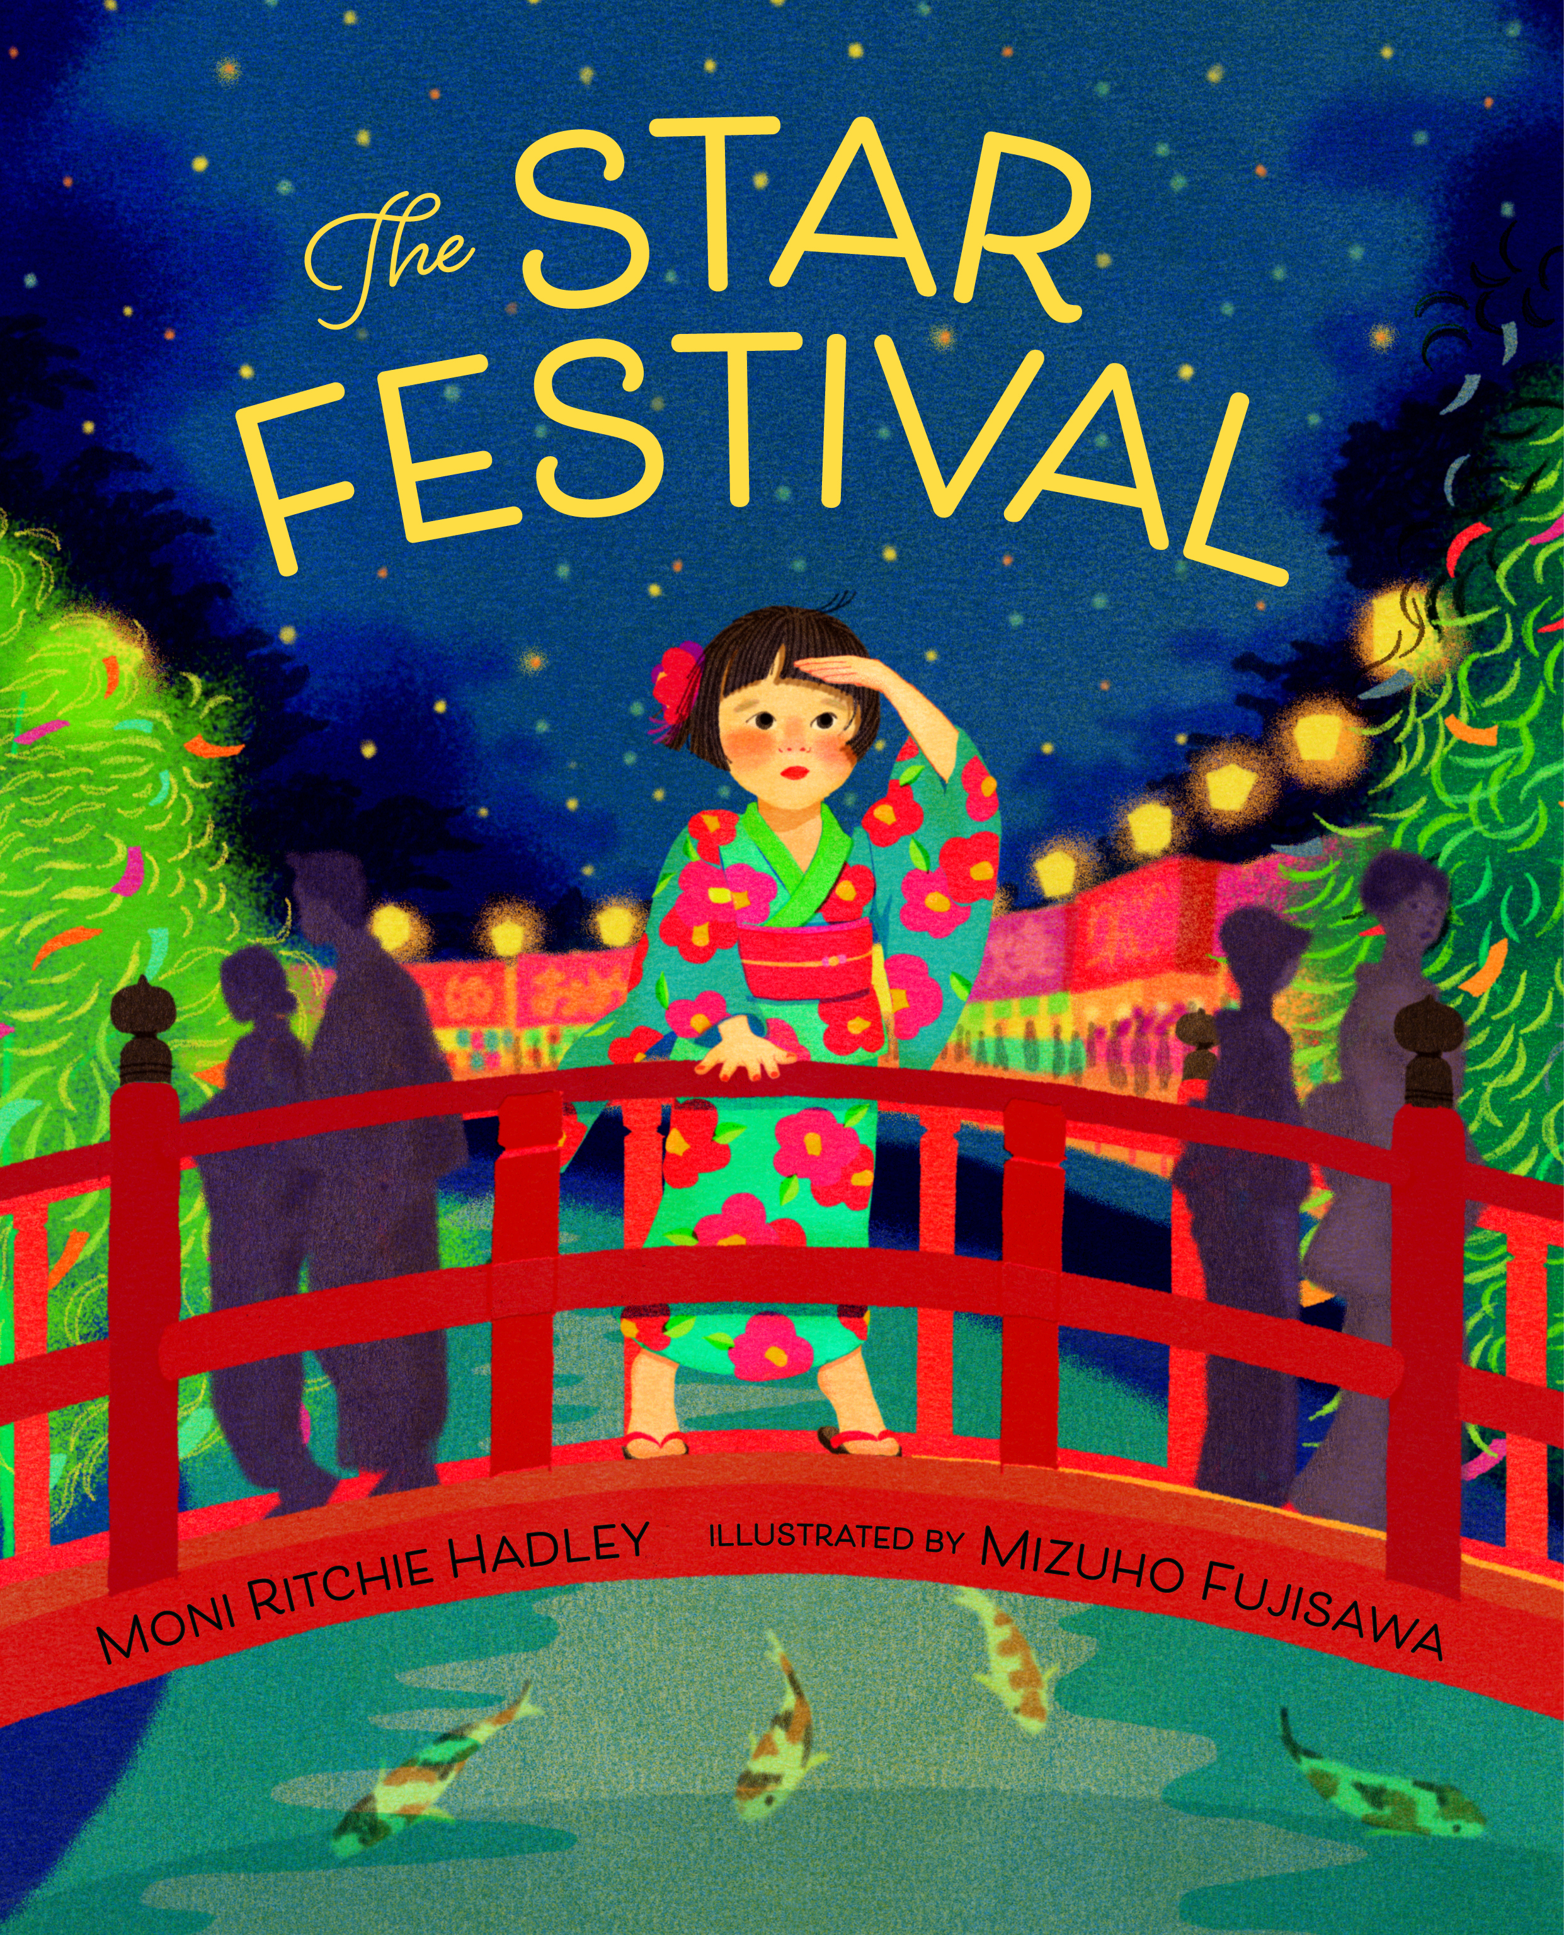
https://www.albertwhitman.com/book/the-star-festival/

